[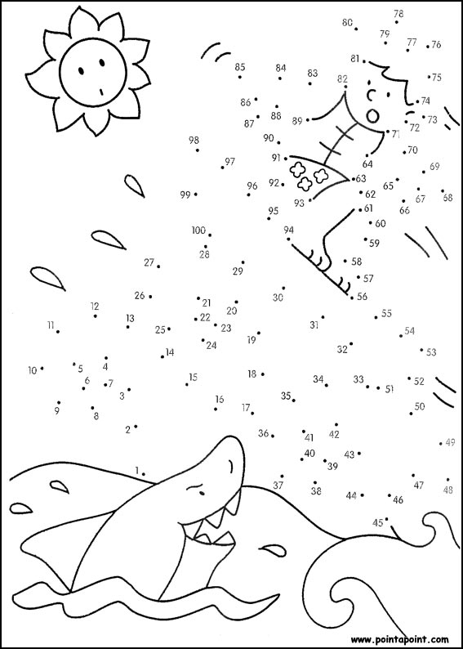](http://www.google.co.uk/url?sa=i&rct=j&q=join+the+dots&source=images&cd=&cad=rja&docid=EdG79mPd70YnvM&tbnid=vRTPFu2zMi-snM:&ved=0CAUQjRw&url=http%3A%2F%2Fwww.connect-the-dots.info%2Fhard_level%2F3-dot-to-dot-03.php&ei=4TACUqiYJIHJ0AW1ooDABg&bvm=bv.50310824,d.d2k&psig=AFQjCNFRN8sMEgpGliGZWZAEpM-RhCgprQ&ust=1375961474607974)